/* Samuel Greenlee */

/* SQL Server */

/* Use Statement for SamsCarsSGG Database */

Use SamsCarsSGG;

/* Stored Procedure One*/

CREATE PROC daysPast

AS

Begin

Select Date_Added, DATEDIFF(Day, Date_Added, GetDate()) As 'Days_Past_Since_Added'

From Car

End;

exec daysPast;

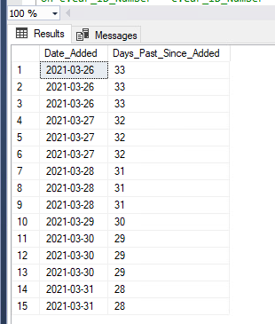

/* Stored Procedure Two */

CREATE PROC EngineMatch

@Engine varchar(30) = ''

AS

Begin

Select Engine_Type, c.Car_ID_Number, Year_Made, UPPER(Make) AS 'Make', UPPER(Model) AS 'Model', UPPER(Drive_Train) AS 'Drive_Train', Date_Added

From Engine as e

Inner Join Car as c

On e.Car_ID_Number = c.Car_ID_Number

Group By Engine_Type, c.Car_ID_Number, Year_Made, Make, Model, Drive_Train, Date_Added

Having Engine_Type Like @Engine

End;

exec EngineMatch 'V6';

